

The **literature review’s main purpose** is to provide context for your research so you can show how your research fills the gaps.

We need to collect the most relevant to your research. I would pick 3-5 for the presentation, but it can depend. Just think about the most important studies and focus on those. You audience needs to have enough background information so that they aren’t confused about the purpose of your research.

**Organized**

Topical(main topics, highlights),

chronological (organized by the dates the research was done),

problem-solution (it moves from the problem to the solution)

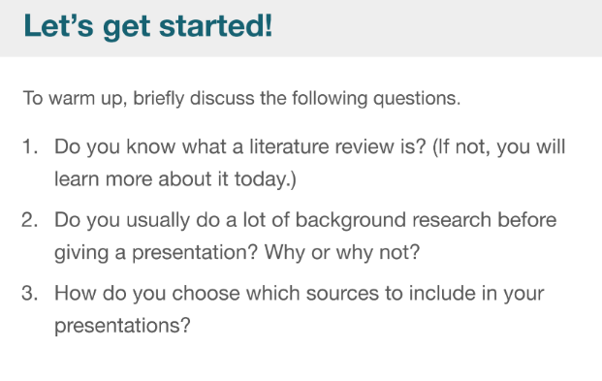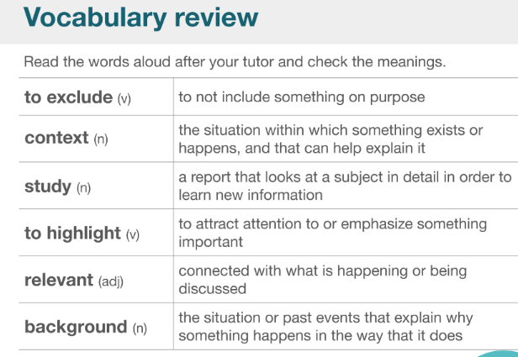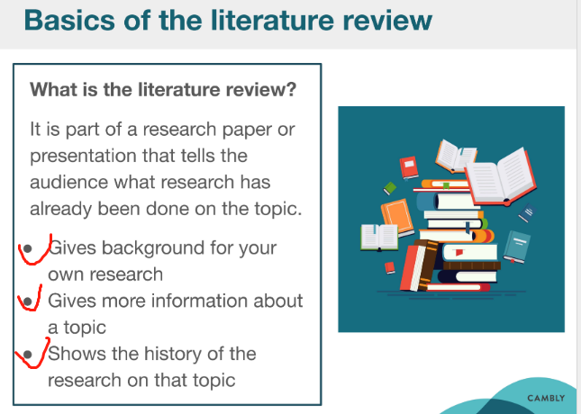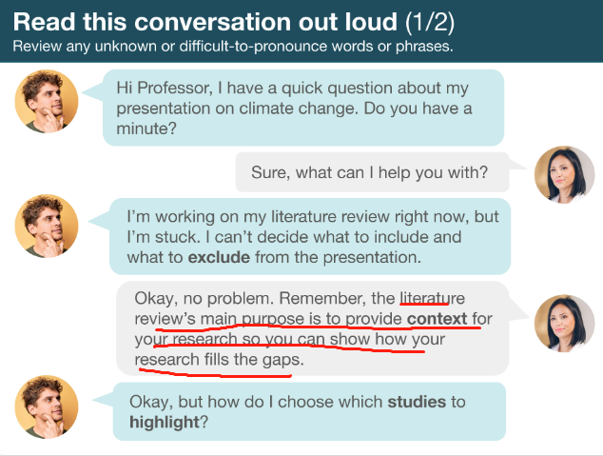

The literature review’s main purpose is to provide context for your research so you can show how your research fills the gaps.

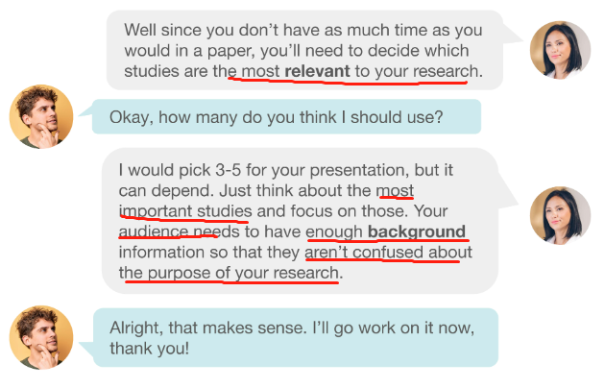

We need to collect the most relevant to your research. I would pick 3-5 for the presentation, but it can depend. Just think about the most important studies and focus on those. You audience needs to have enough background information so that they aren’t confused about the purpose of your research.

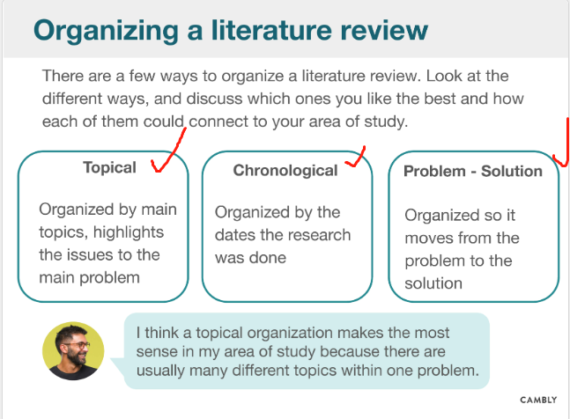

Topical(main topics, highlights),

chronological (organized by the dates the research was done),

problem-solution (it moves from the problem to the solution)

